Python Crash Course: Using Atlas

Launch Jupyter on Atlas

Using Atlas requires that you have a SCINet account.

Launching a JupyterLab session on Atlas involves specifying the compute resources that your session will use. The job scheduler on Atlas needs information about the resources your job will need and the account to use. See the details below for the settings to use.

We will use the Open OnDemand (OOD) web interface to launch and connect to Jupyter sessions. OOD provides an easy interface to provide the resource request, submit the job to the scheduler, and connect to the Jupyter server once it starts.

Steps to launch a JupyterLab session

* Login at: <https://atlas-ood.hpc.msstate.edu/pun/sys/dashboard>
* Use the USDA LincPass method. If you do not have a LincPass, see [**alternative log-in instructions on the SCINet website**](https://scinet.usda.gov/guides/access/login).
* Click on the **Interactive Apps** menu and select **Jupyter**

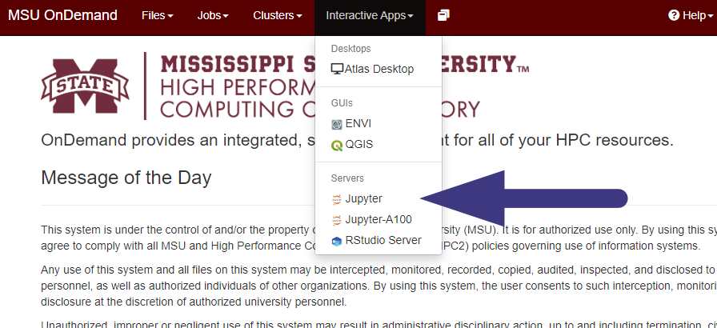

* The next screen allows you to request resources to run a job on Atlas.
* See the image for reference, but the suggested resource request for most of the *Practicum AI* courses is:

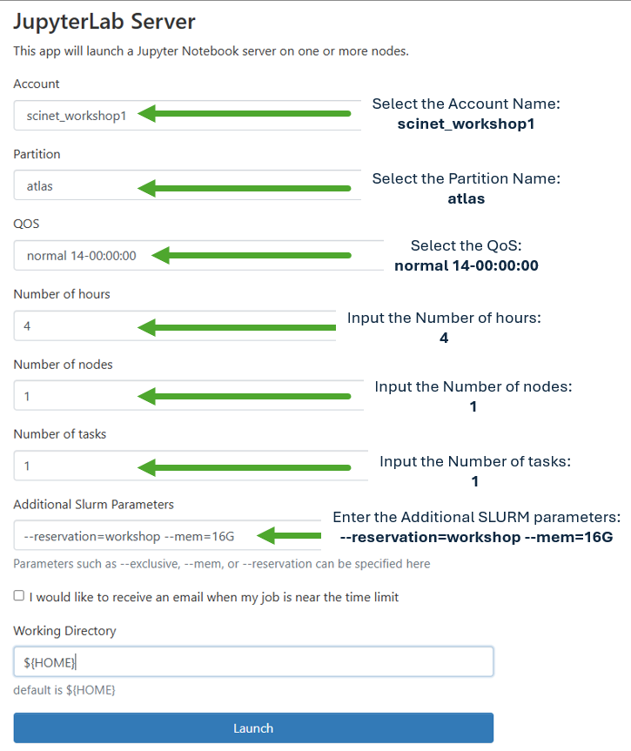

* Lab or Notebook: **JupyterLab**
* Account Name: **scinet_workshop1**
* Partition Name: **atlas**
* QOS: **normal**
* Number of hours: **4**
* Number of nodes: **1**
* Number of tasks: **1**
* Additional Slurm Parameters:

**--reservation=workshop --mem=16G**

* After entering the information, click the Launch button.
* 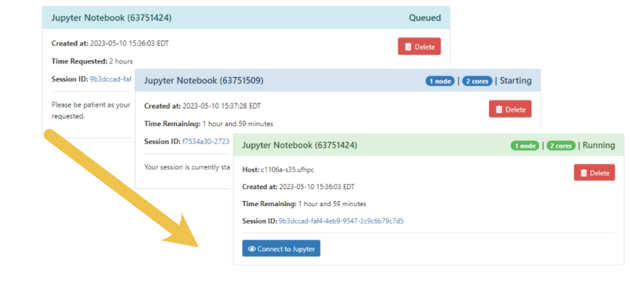On the next page, your job will have a card. The card will start with a light blue border with “Queued” in the upper right. That means your job has been submitted to the scheduler and is waiting for the scheduler to find resources (or for them to be available in your group’s allocation). Once the resources are available, the card will change to a dark blue border with “Starting” and finally, when your job is ready, it will have a green border, say “Running” and have a button to click to “**Connect to Jupyter**”.
* Clicking the Connect to Jupyter button will open a new tab and should open with a window like what is pictured below—on future connections, it will normally open with the documents you left opened last time.

A screenshot of the Jupyter Interface once it opens.
